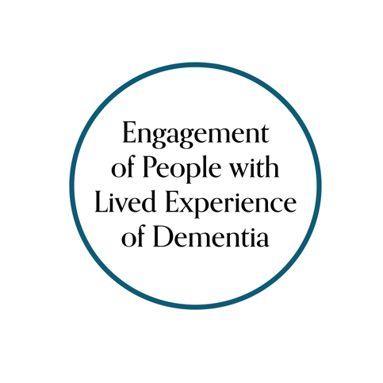
Canadian Consortium on Neurodegeneration in Aging (CCNA) Engagement of People with Lived Experience of Dementia (EPLED) Advisory Group
Working with the Advisory Group

Thank you for your interest in working with the CCNA EPLED Advisory Group. We ask you to please complete this questionnaire in order to provide some information about your request and help us plan how we might work together.
Before beginning the questionnaire, please consider the following checklist. To consult with the Advisory Group, you must:
- Be a CCNA researcher or trainee
- Have a project that requires lived experience input and analysis; in other words, you are not looking for study subjects, you are seeking collaborators with lived experience who will provide input in planning, conducting or communicating your research
- Meet with our EPLED team to discuss your request
- Submit background materials at least two weeks in advance of any regularly scheduled or ad hoc Advisory Group meeting(s)
- Communicate in plain language (i.e., in presentations and written documents provided to the Advisory Group)
- Co-facilitate the Advisory Group consultation(s) with a member of the EPLED team and/or Advisory Group
- Report back to the Advisory Group on how their input was used in the project
Please complete this form and return to Ellen Snowball ellen.snowball@uhn.ca
Your name: _________________________________________________
Your email address: __________________________________________
Other co-investigators/collaborators involved in the project
- From within CCNA, please list names with CCNA theme(s)/team(s)/program(s)/platform(s):
- From outside CCNA, please list names with institutions:

Name of the project: _____________________________________________
Please provide a short, structured description of the project and include each heading listed (as applicable) (limit: 250 words)
Background:
Objective(s):
Methods:
Results (if applicable):
How will this project impact the lives of people living with dementia, their friends/family/caregivers/care partners or those at risk of dementia? (limit: 100 words)

What stage is your project at? (e.g., applying for funding, analyzing data, preparing publications)

Who are you interested in engaging in your project? (check only one)
- People with dementia
- Friends/family/caregivers/care partners of people with dementia
- Both
Are there other characteristics or experiences you are looking for? (e.g., young carer, early onset dementia, long-term care homes, rural, etc.)

Are you interested in engaging the entire Advisory Group, or only some members (i.e., with these characteristics or experiences)? (check only one)
- Entire Advisory Group
- Only some members of the Advisory Group
- Not sure

At what stage are you looking to engage the EPLED Advisory Group in your project? (check all that apply)
- Governance (e.g., contributing to study oversight)
- Priority setting (e.g., helping to refine research questions)
- Study design and procedures (e.g., selecting outcomes, reviewing consent procedures and study documents)
- Study recruitment (e.g., suggesting avenues to recruit study participants)
- Data collection (e.g., conducting interviews)
- Data analysis (e.g., interpreting findings)
- Knowledge translation (e.g., coauthoring publications or presentations)
- Other – please specify:
What is your specific “ask” for the EPLED Advisory Group? (limit: 500 words)
Have you already incorporated other lived experience engagement activities into this project? If yes, please describe.

Are you submitting or planning to submit any background documents? If yes, please list them below and briefly describe how they relate to your project and engagement work.

Do you have plans to evaluate the impact of this engagement? If yes, please elaborate.

