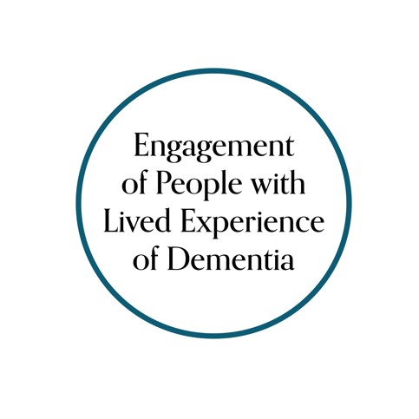

Canadian Consortium on Neurodegeneration in Aging
(
CCNA
)

Engagement of People with Lived Experience of
Dementia (EPLED) Advisory Group

Role Profile 2.0

Position title: Lived Experience Advisory Group member
Background & purpose: Engagement of People with Lived Experience of Dementia (EPLED) was a cross-cutting program introduced to the Canadian Consortium on Neurodegeneration in Aging (CCNA) in Phase II. We aim to engage persons with dementia and care partners in CCNA research – not as study subjects, but as collaborators in planning, conducting and communicating research. In doing so, we believe it will make dementia research better and more relevant.
People with lived experience of dementia include:
- People living with dementia (e.g., you have received diagnosis or in process of obtaining)
- Current and former friends or family members of a person living with dementia
- Current and former caregivers/care partners of a person living with dementia
*Note: people living with dementia and friends, family, care partners and caregivers are invited to participate individually or as a pair (e.g., person with dementia and care partner).
Location: Meetings will be held by computer (video/tele-conference). There may also be one or more in-person meetings each year (in Canada).
Key responsibilities: As an Advisory Group member you will be required to attend meetings and participate in discussions. During the meetings, you may hear from researchers and you will have an opportunity to ask questions and offer your insights, such as by:
- Providing input on research questions and aspects of study design (e.g., ensuring methods are acceptable and equitable for potential research participants).
- Reviewing study documents (e.g., ensuring language and content of consent forms and data collection methods are appropriate and accessible).
- Analyzing and interpreting data (e.g., contextualizing results by providing perspectives of lived experience).
- Assisting with knowledge translation (e.g., helping to ensure study results are communicated in a way that is accessible and meaningful).
Length of appointment: We will ask Advisory Group members to commit to a 2-year term that can be extended to a second 2-year term (maximum 4 years). Four formal online meetings and monthly informal meetings are held in the one-year period:
- Virtual (video/tele-conference) meetings will be held during the day, generally lasting 1-2 hours.
- In-person meetings will be held in Canada, generally lasting a day or more.
Support provided: You will receive training for the role, including a general orientation to health research and the CCNA. In addition, Ellen Snowball (EPLED Coordinator) and Jennifer Bethell (EPLED co-lead) will be available for questions and assistance during your appointment to the Advisory Group:
Ellen Snowball
Research Associate
Toronto Rehabilitation Institute – University Health Network
Bickle Centre - RESEARCH
130 Dunn Ave
Toronto, ON M6K 2R8
Email: ellen.snowball@uhn.ca

Jennifer Bethell, PhD
Affiliate Scientist
Toronto Rehabilitation Institute – University Health Network
Bickle Centre - RESEARCH
130 Dunn Ave
Toronto, ON M6K 2R8
Tel: 647-649-7321 / Email: jennifer.bethell@uhn.ca

Compensation: You will be reimbursed for travel expenses (e.g., to attend in-person meetings) and offered a yearly non-taxable $500 honorarium for your participation.

