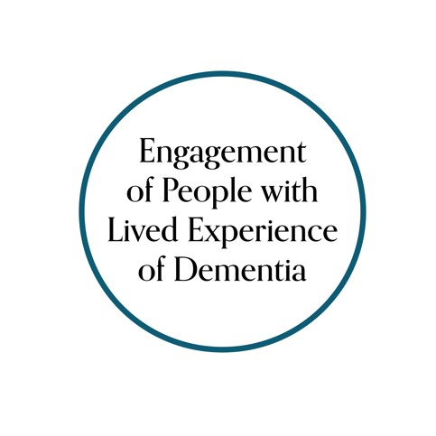

Canadian Consortium on Neurodegeneration in Aging
(
CCNA
)

Engagement of People with Lived Experience of
Dementia (EPLED) Advisory Group

Terms of Reference 2.0

Background
Engagement of People with Lived Experience of Dementia (EPLED) was a cross-cutting program introduced to the Canadian Consortium on Neurodegeneration in Aging (CCNA) in Phase II. The objectives of the EPLED program are to:
- Support persons with dementia and care partners to be actively involved in the research process;
- Work with CCNA research teams, cross-cutting programs and partners, as well as external research teams, to develop novel mechanisms and formats to further this collaboration; and
- Advance the methods of patient engagement in research, for persons with dementia and care partners, by embedding evaluation processes that will measure the impact of these initiatives.

Purpose
The Advisory Group furthers the objectives of the EPLED program by providing a venue for researchers to engage people with lived experience of dementia in their projects - not as study subjects, but as collaborators in planning, conducting and communicating research. This engagement might include, for example:
- Providing input on research questions and aspects of study design (e.g., ensuring methods are acceptable and equitable for potential research participants).
- Reviewing study documents (e.g., ensuring language and content of consent forms and data collection methods are appropriate and accessible).
- Analysing and interpreting data (e.g., contextualizing results by providing perspectives of lived experience).
- Assisting with knowledge translation (e.g., helping to ensure study results are communicated in a way that is accessible and meaningful).
- Participating as collaborators on grant applications, coauthors on academic publications or other reports, creation of plain language virtual and non-virtual content.
Guiding Principles
Underpinning the work of the Advisory Group are the guiding principles identified by the Canadian Institutes of Health Research (CIHR) Strategy for Patient Oriented Research (SPOR) Patient Engagement Framework and University Health Network (UHN) Pride in Patient Engagement in Research (PiPER) Toolkit. These principles include:
- Inclusion, Diversity, Equity, Accessibility (IDEA): Patient engagement in research integrates a diversity of lived experience perspectives and research is reflective of their contribution – i.e., people with lived experience are bringing their lives into this. EPLED recognizes that diverse groups have been traditionally excluded from research. We utilize a trauma-informed, heath-equity lens to build relationships based on mutual trust and respect.
- Support: Support and flexibility are provided to participants to ensure that they can contribute fully to discussions and decisions. EPLED strives to create safe meeting environments focused on collaboration. We offer a yearly honorarium Advisory Group members as a way of recognizing their expertise, time and contributions. Leads and staff will be available to meet individually upon request.
- Mutual Respect: Researchers, practitioners and people with lived experience acknowledge and value each other's expertise and experiential knowledge. EPLED recognizes that humility is fundamental to addressing power differentials and building trust. We enter into research partnerships reflexive of our expertise and internalized bias and also open to the ideas and approaches of others.
- Collaboration: People with lived experience, researchers and practitioners work together from the beginning to identify problems and gaps, set priorities for research and work together to produce and implement solutions. We recognize that different perspectives are needed to address the complex challenges associated with dementia. We work to collaborate across disciplines, themes and topics of research.
For more on our guiding principles, please see our EPLED program policy.

Membership
The Advisory Group has a membership of no more than 15 people. They all have lived experience of dementia, that is, are people living with dementia and/or friends, family and caregivers/care partners (current or former). Members are selected by the EPLED Program Leads. Members have both shared and unique experiences of dementia. They are diverse with respect to their age, sex/gender, geographical locale within Canada, race and ethnicity, health experiences, work, cultural and educational backgrounds, and volunteer/caregiver experiences. As part of their work with the Advisory Group, they endeavor to:
- Respect diversity and differing opinions
- Work collaboratively with other people with lived experience, researchers and practitioners
- Respect the opinions, time, privacy and confidentiality of other members
- Openly and candidly share their ideas and provide constructive feedback

Members Responsibilities
As part of their commitment to the Advisory Group, Members are asked to:
- Complete training and orientation sessions
- Attend in-person meetings, in Canada (if possible)
- Participate in video/tele-conferences during the remainder of the year
- Join ad hoc meetings related to specific research projects and other CCNA-related activities*
- Inform the program leads or staff liaison if they will miss a meeting or need additional support
- Submit all documents for compensation in a timely manner (including receipts for reimbursement)
- Provide constructive input at meetings and conferences
* Participation in specific research projects and other CCNA-related activities is at the discretion of individual members; not all initiatives will be of interest to every member and there is no obligation to participate in any particular initiative.

Membership Term
We will ask Advisory Group members to commit to a 2-year term that can be extended to a second 2-year term (maximum: 4 years). Terms help to ensure new perspectives are introduced. Membership structure will compose of two groups: a “core” group of active members and an “alumni” group of past members. Alumni members who wish to continue their involvement with EPLED and CCNA will have opportunities to do so. Advisory Group terms will be staggered to avoid onboarding or offboarding at once. Advisory Group members can resign at any time.
Support for Members
As orientation, members are provided with an introduction to the Canadian Consortium on Neurodegeneration in Aging (CCNA) and participate in Canadian Institutes of Health Research (CIHR) “Fundamentals of Health Research in Canada” training. Before each meeting, members are provided with background materials to help prepare and a contact person to whom they can direct questions. Members are supported to carry out their work as part of the Advisory Group. This support includes help with any accessibility considerations or practical assistance, such as making travel arrangements. EPLED hosts a monthly virtual social gathering.

Compensation and Reimbursement for Members
Members are offered $500 per year non-taxable honorarium for their contributions to the Advisory Group. Expenses, such as costs of travel, accommodation and meals (including expenses of support person, as required) for any meetings will also be reimbursed in accordance with University Health Network (UHN) policy. For participation on specific research projects, principal investigators are encouraged to offer compensation separate from the Advisory Group honorarium.

Stepping Down
Circumstances can change and members may find they can no longer participate on the
Advisory Group. In this case, they will inform the EPLED program staff of their intentions.

Advisory Group Meeting Procedures
Quarterly formal meetings will be chaired by a rotating EPLED Advisory Group member. The chair will be supported by the EPLED Program Lead(s), Staff Liaison and Alumni in meeting preparation (e.g., drafting and circulating agendas, arranging meeting logistics, etc.). The Advisory Group will strive for consensus and will use voting when there is no clear agreement. Meeting minutes and/or recording virtual meetings will be arranged by the EPLED Staff Liaison and circulated by email to Advisory Group members. Minutes may be circulated to others, on request.

Working with CCNA Researchers
CCNA and other researchers will approach and engage the Advisory Group through the EPLED program. Researchers will describe their engagement opportunity to the Advisory Group, in writing (and with a presentation, where requested by the Advisory Group), for review and prior to any engagement work. Engagement opportunities may be relevant to the entire Advisory Group, or only some members, and either scenario will be supported. Advisory group members are encouraged to ask for clarification on any and all aspects of the research.

Terms of Reference Review
The Advisory Group will review these terms of reference every as required and approve revisions.

Communications with EPLED Program
Advisory Group members can communicate directly with any of:
- Jennifer Bethell (Program co-lead): Jennifer.bethell@uhn.ca
- Ellen Snowball (Program coordinator): ellen.snowball@uhn.ca

Ellen Snowball supports the Advisory Group by coordinating activities, including meetings and communications.

